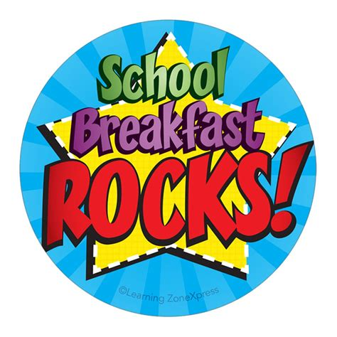
PK, K 1st- 5th
Breakfast Menu
SERVED DAILY
Fresh Fruit
100 % Fruit Juice M-T-W-F 1% White Or Fat Free Flavored Milk

MONDAY | TUESDAY | WEDNESDAY | THURSDAY | FRIDAY
WEEK 1

Muffin W/ Cheese Stick  Fruit Juice  Fresh Fruit  Jelly/Syrup | Breakfast Pizza  Craisins  Fruit Juice  Jelly | Cereal W/Graham Cracker  Fruit Juice  Fresh Fruit  Jelly/Syrup | Biscuit W/Sausage  Fresh Fruit  Chilled Fruit  Jelly | Mini Pancakes  Fruit Juice  Fresh Fruit  Jelly/Salsa/Syrup
WEEK 2
Mini Waffles  Fruit Juice  Fresh Fruit  Jelly/Syrup | Cereal W/Graham Cracker  Fresh Fruit  Fruit Juice  Syrup | Breakfast Sausage Wrap  Fruit Juice  Craisins  Jelly/Syrup | Ham & Cheese Croissant  Fresh Fruit  Chilled Fruit  Jelly | Cereal W/Graham Cracker  Fruit Juice  Fresh Fruit  Jelly/ Syrup
WEEK 3
Muffin W/ Cheese Stick  Fruit Juice  Fresh Fruit  Jelly/Syrup | Breakfast Pizza  Craisins  Fruit Juice  Jelly | Cereal W/Graham Cracker  Fruit Juice  Fresh Fruit  Jelly/Syrup | Biscuit W/Sausage  Fresh Fruit  Chilled Fruit  Jelly | Mini Pancakes  Fruit Juice  Fresh Fruit  Jelly/Salsa/Syrup
WEEK 4
Mini Waffles  Fruit Juice  Fresh Fruit  Jelly/Syrup | Cereal W/Graham Cracker  Fresh Fruit  Fruit Juice  Syrup | Breakfast Sausage Wrap  Fruit Juice  Craisins  Jelly/Syrup | Ham & Cheese Croissant  Fresh Fruit  Chilled Fruit  Jelly | Cereal W/Graham Cracker  Fruit Juice  Fresh Fruit  Jelly/ Syrup

